| Description | Issues | Input | Output | Challenges |
| --- | --- | --- | --- | --- |
| Conceptual Design | - Capturing all data | - considering types of input and identifying them | - ER diagram | Missing important data. |
| Logical Design | Missing logic | Considering data types | Identified data type of the data | Breaking the logic |
| Physical Design | Resource availability | drives | Storage setup | Amount of drives needed |
| Secure Design | Which model to use | Security method | Secure database | Security model weakness |

1. 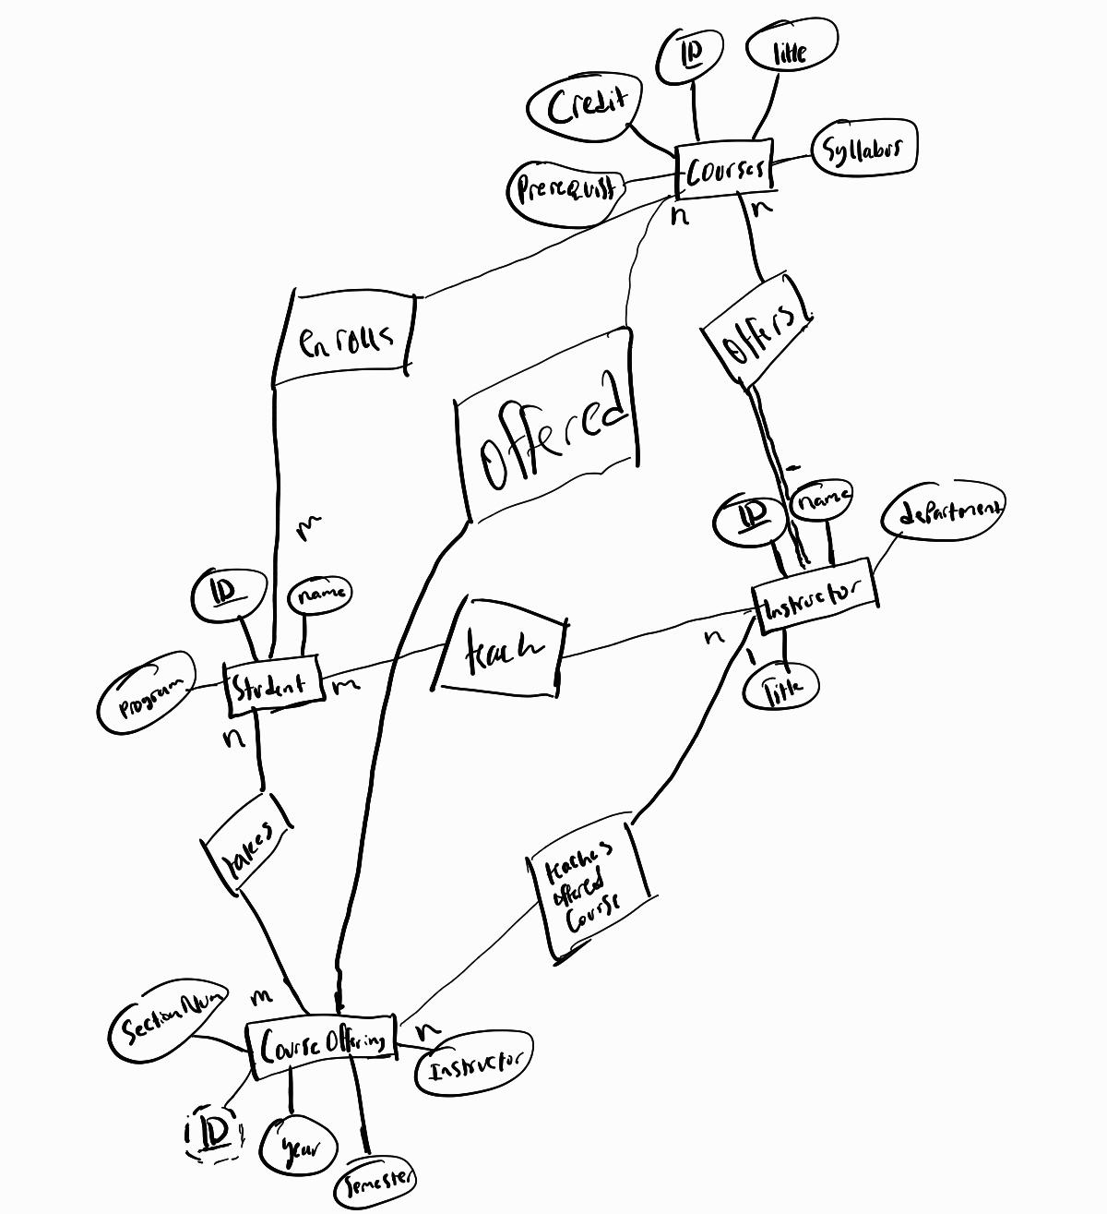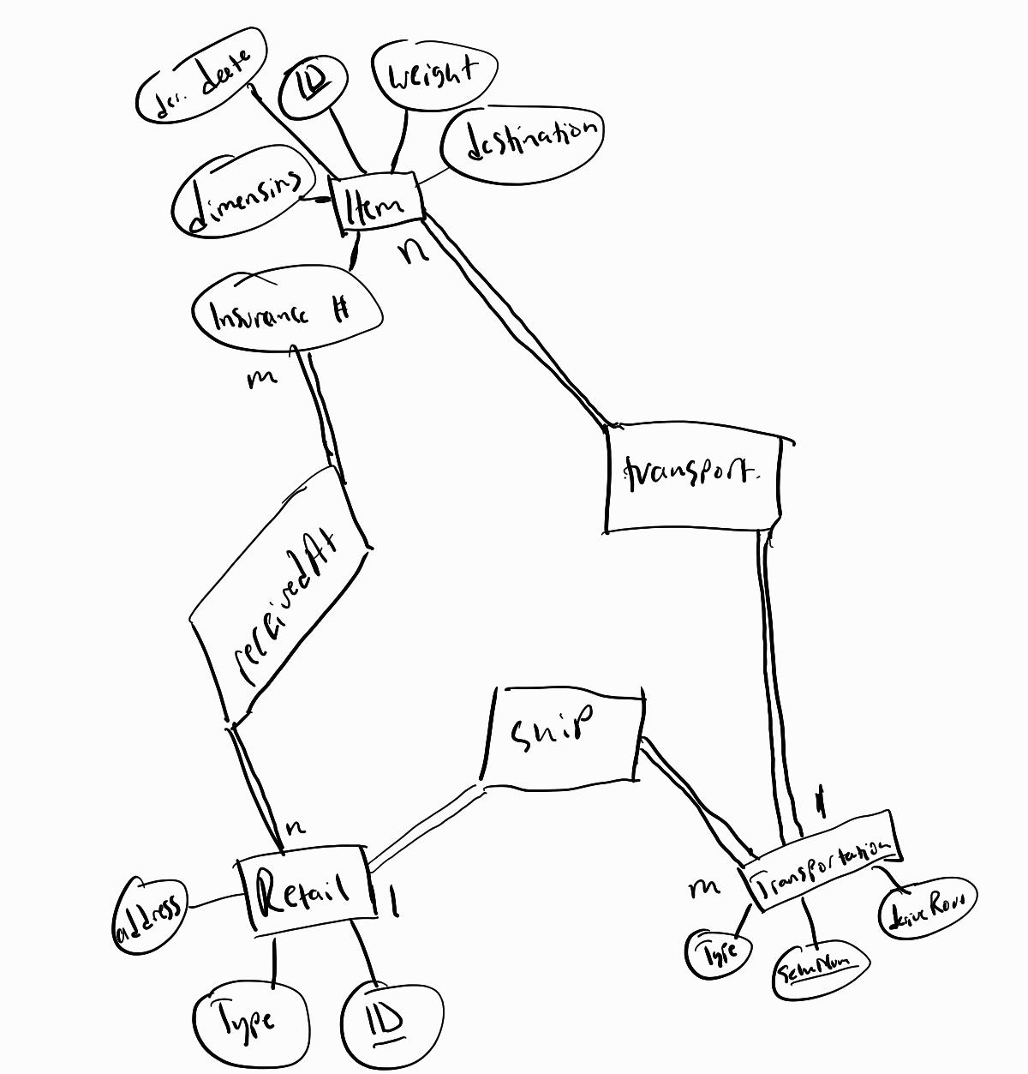
2. 